Lab practical

Lab 1: Create a new database named school_db and a table called students with the following columns: student_id, student_name, age, class, and address. •
create database student;
use student
- create table student( student_id int primary key auto_increment,student_name varchar(100),age int ,class varchar(100),address varchar(100));

Lab 2: Insert five records into the students table and retrieve all records using the SELECT statement.
insert into student(student_name,age,class,address) values('sneha',21,'1st year','25 sarthana'),
('shruti',22,'12th','nana varacha'),
('smit',19,'11th','mota varacha'),
('diksha',19,'11th','dindoli'),
('bansi',23,'12th','udhna darwaza');

Select * from student;

• Lab 1: Write SQL queries to retrieve specific columns (student_name and age) from the students table
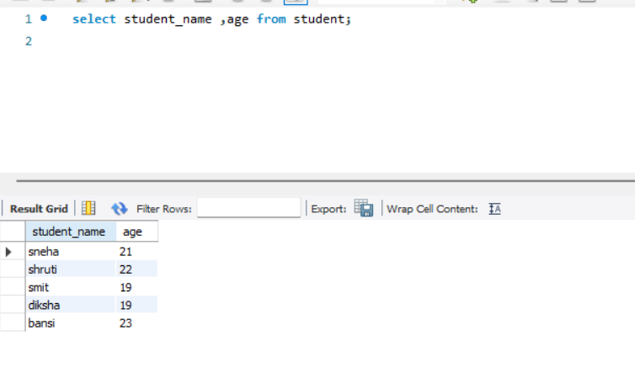
. • Lab 2: Write SQL queries to retrieve all students whose age is greater than 10.
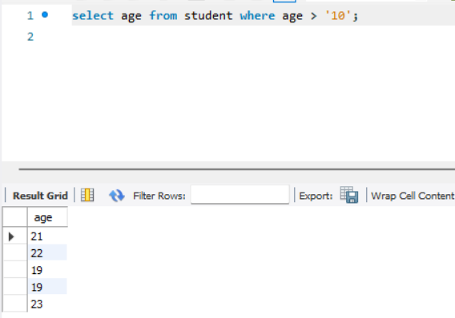

• Lab 1: Create a table teachers with the following columns: teacher_id (Primary Key), teacher_name (NOT NULL), subject (NOT NULL), and email (UNIQUE).
create table teacher(teacher_id int Primary Key , teacher_name varchar(100) NOT NULL, sub varchar(100) NOT NULL, email varchar(100) UNIQUE);
select*from teacher;
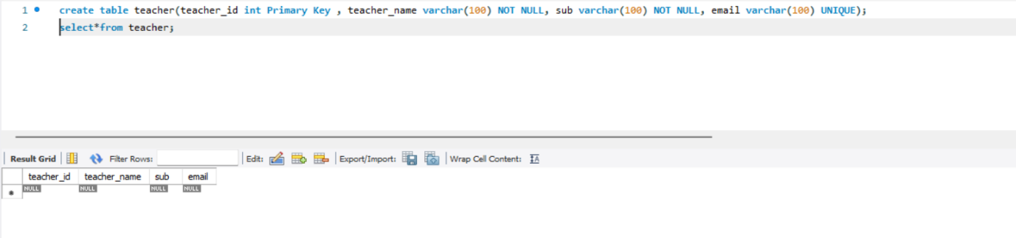
• Lab 2: Implement a FOREIGN KEY constraint to relate the teacher_id from the teachers table with the students table.
alter table student add teacher_id int;
alter table student add constraint fk_teacher foreign key(teacher_id) references teacher(teacher_id);
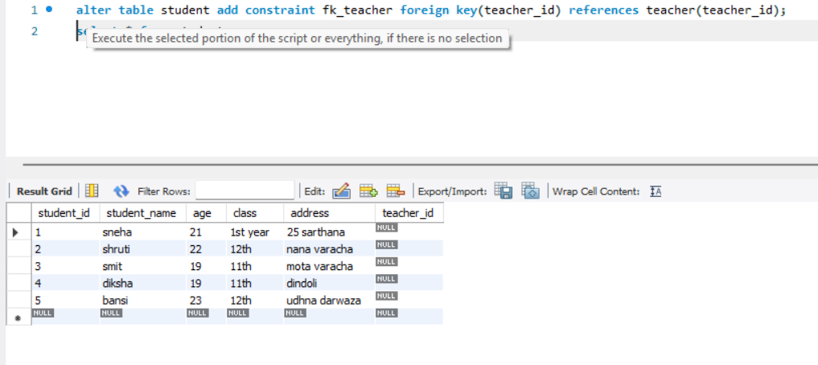

Lab 1: Create a table courses with columns: course_id, course_name, and course_credits. Set the course_id as the primary key.
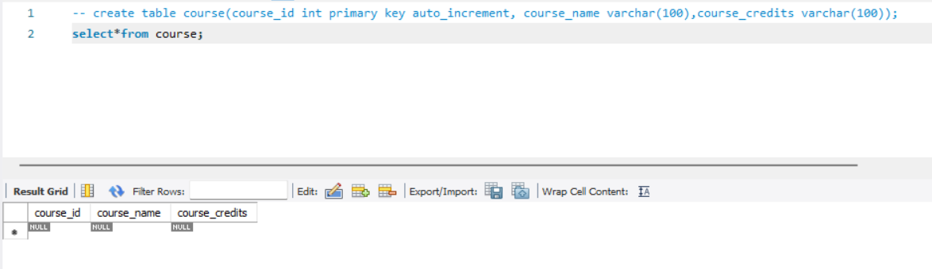

• Lab 2: Use the CREATE command to create a database university_db.
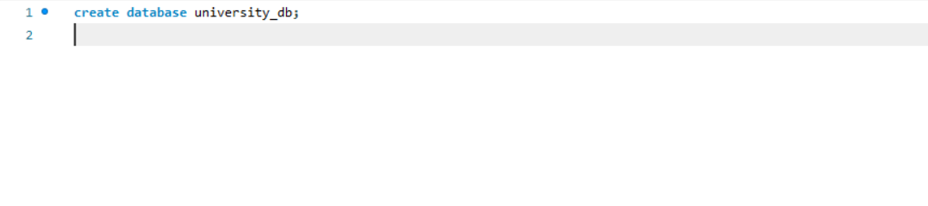

Lab 1: Modify the courses table by adding a column course_duration using the ALTER command.
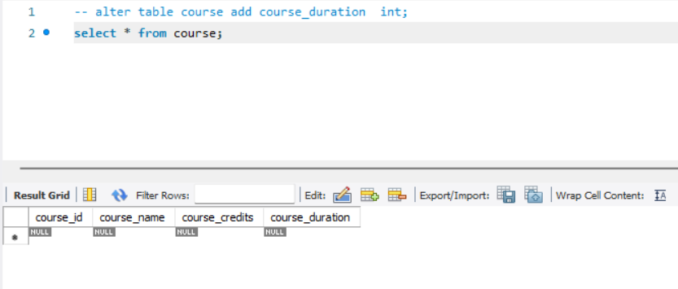

Lab 2: Drop the course_credits column from the courses table.
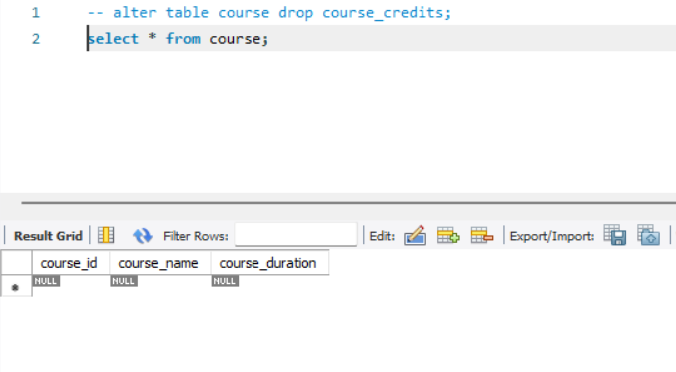

Lab 1: Drop the teachers table from the school_db database.
• Lab 2: Drop the students table from the school_db database and verify that the table has been removed.
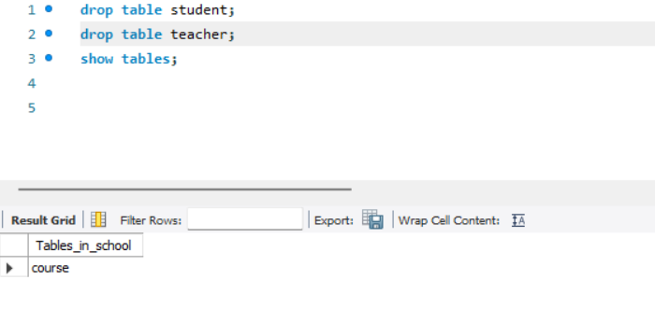

Lab 1: Retrieve all courses from the courses table using the SELECT statement.
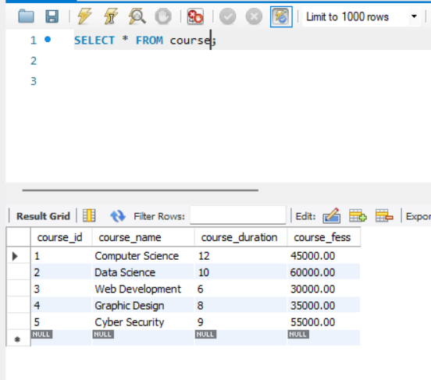
• Lab 2: Sort the courses based on course_duration in descending order using ORDER BY.
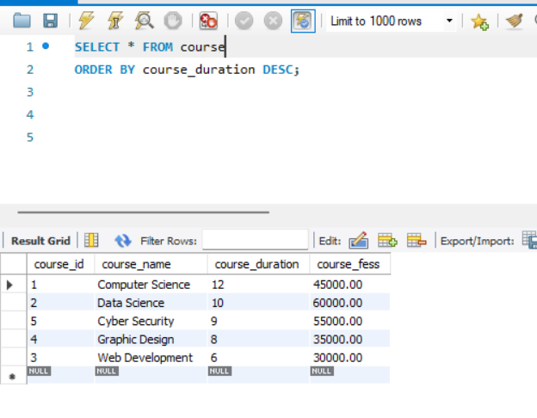
• Lab 3: Limit the results of the SELECT query to show only the top two courses using LIMIT.
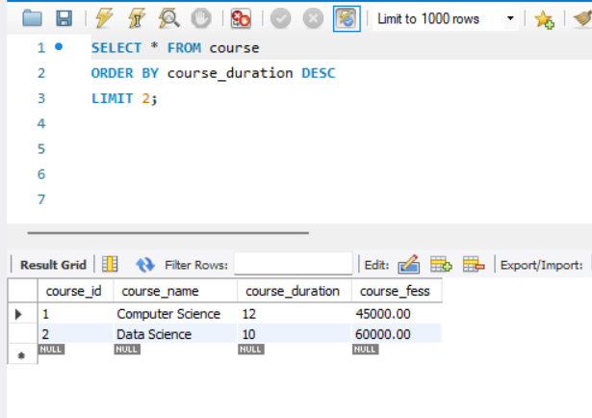

Lab 1: Create two new users user1 and user2 and grant user1 permission to SELECT from the courses table.

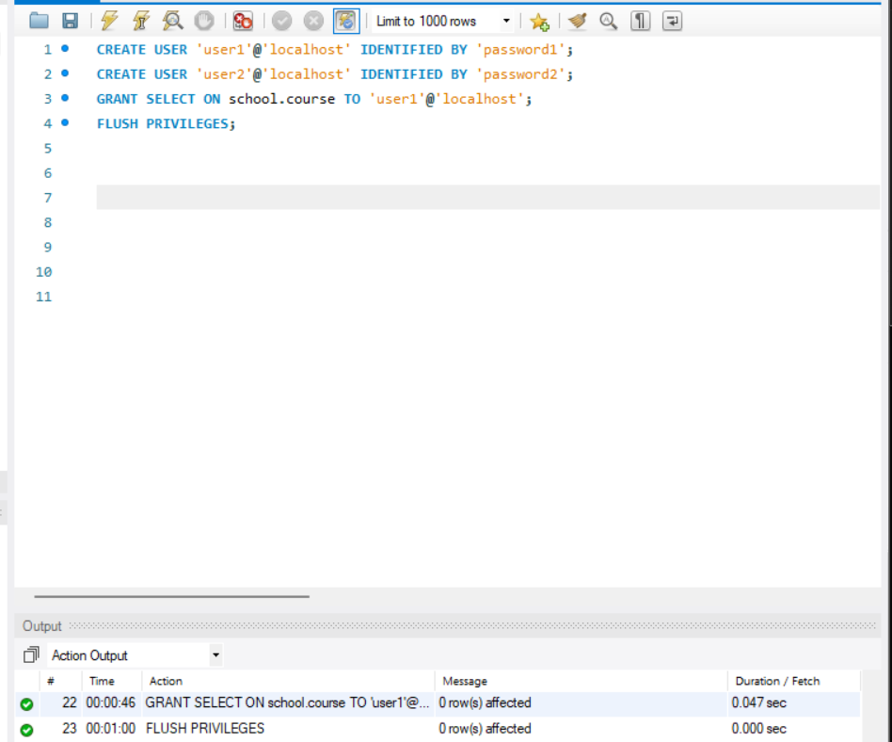

• Lab 2: Revoke the INSERT permission from user1 and give it to user2.
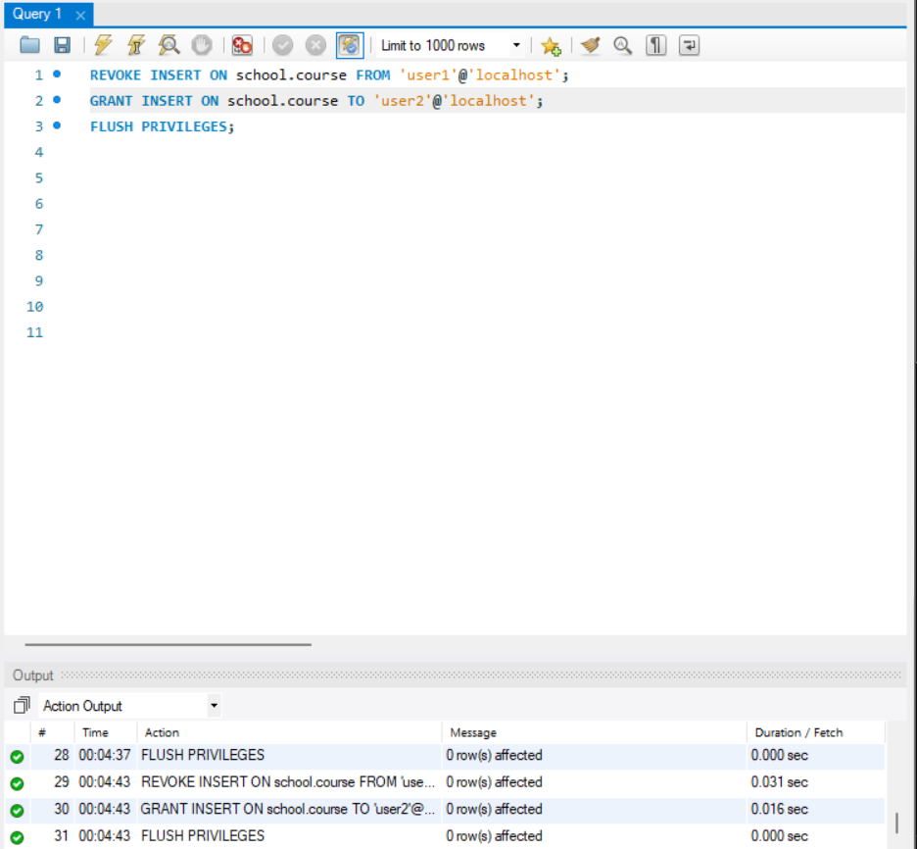

Lab 1: Insert a few rows into the courses table and use COMMIT to save the changes.
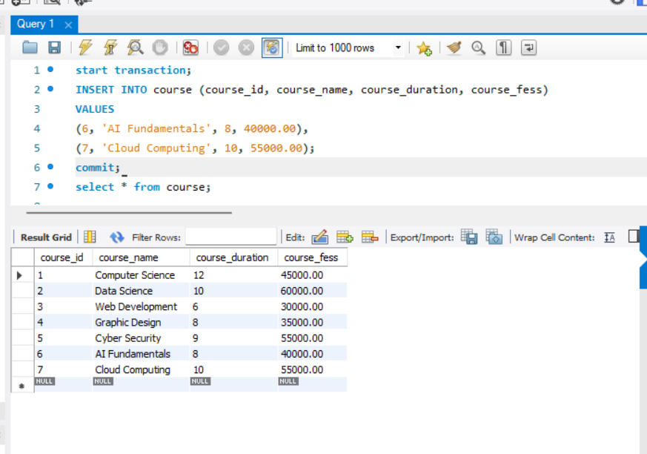
• Lab 2: Insert additional rows, then use ROLLBACK to undo the last insert operation. •
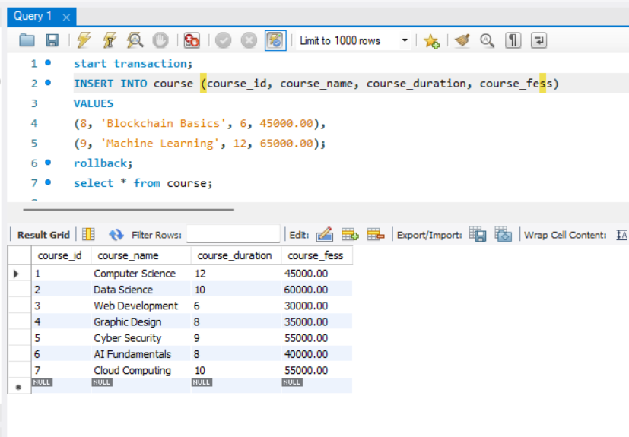
Lab 3: Create a SAVEPOINT before updating the courses table, and use it to roll back specific changes.
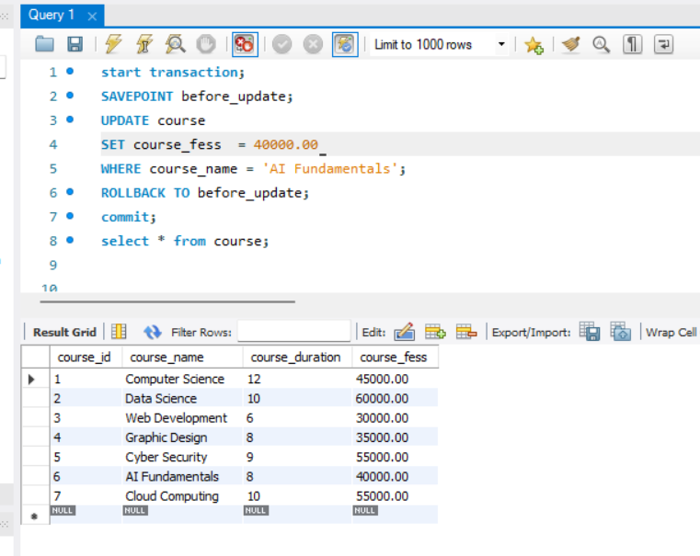

Lab 1: Create two tables: departments and employees. Perform an INNER JOIN to display employees along with their respective departments.
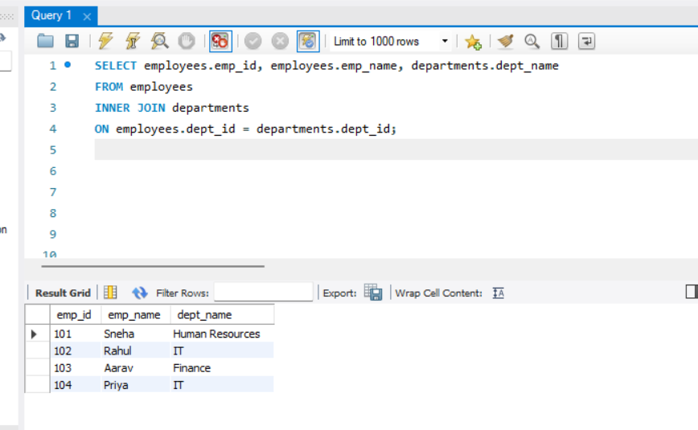

• Lab 2: Use a LEFT JOIN to show all departments, even those without employees.
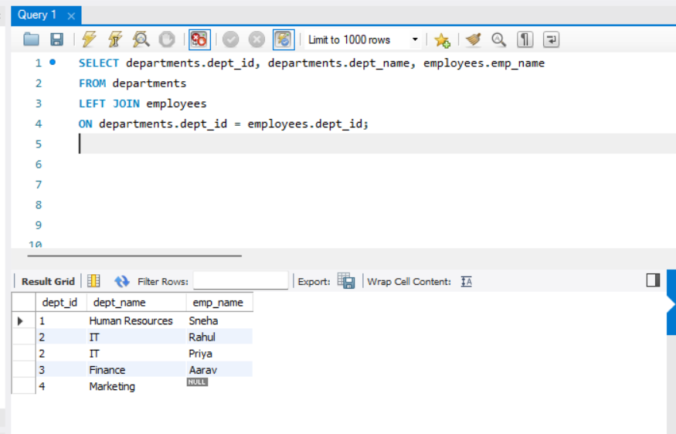

Lab 1: Group employees by department and count the number of employees in each department using GROUP BY. • Lab 2: Use the AVG aggregate function to find the average salary of employees in each department.
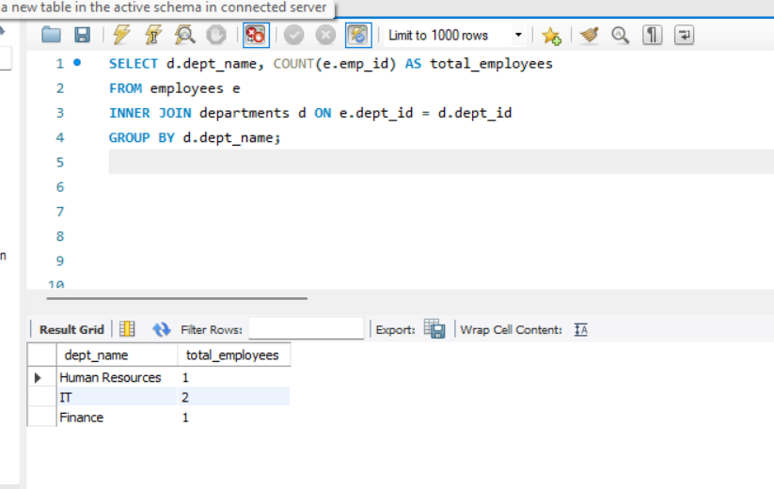

Lab 1: Write a stored procedure to retrieve all employees from the employees table based on department.
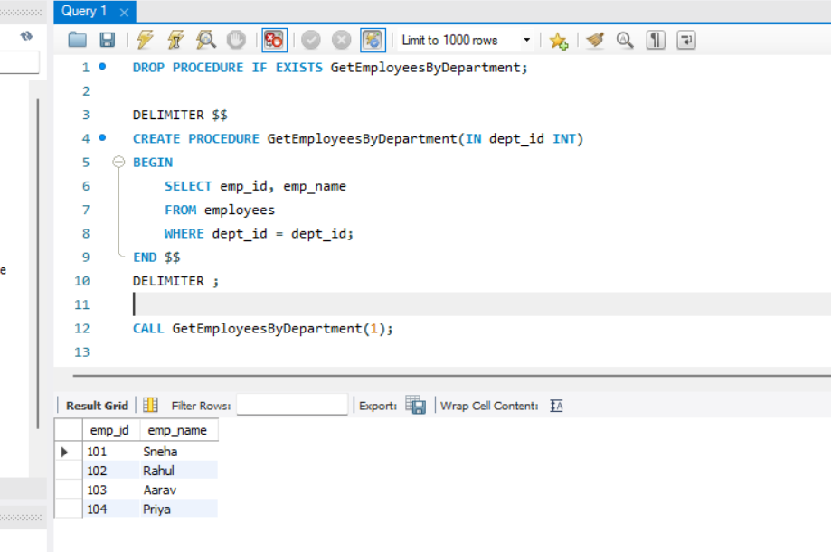
• Lab 2: Write a stored procedure that accepts course_id as input and returns the course details.
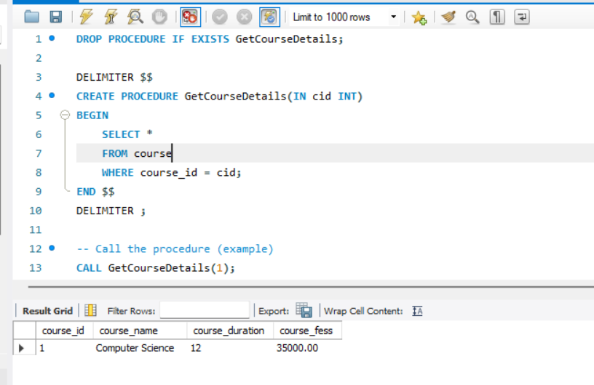

Lab 1: Create a view to show all employees along with their department names.
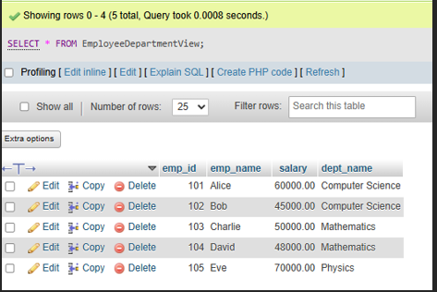
• Lab 2: Modify the view to exclude employees whose salaries are below $50,000.
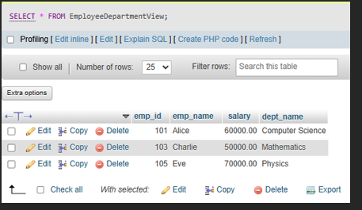

Lab 1: Create a trigger to automatically log changes to the employees table when a new employee is added.
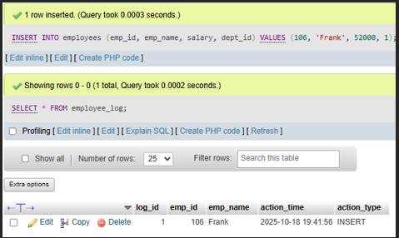
• Lab 2: Create a trigger to update the last_modified timestamp whenever an employee record is updated.
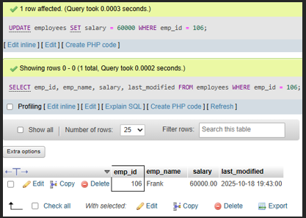
Lab 1: Write a PL/SQL block to print the total number of employees from the employees table.
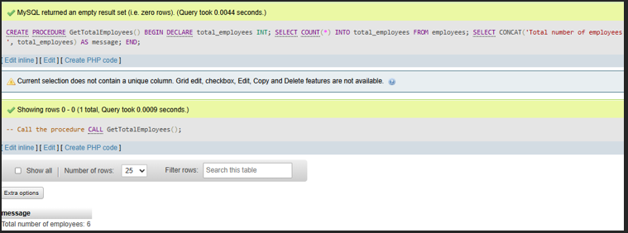
• Lab 2: Create a PL/SQL block that calculates the total sales from an orders table.
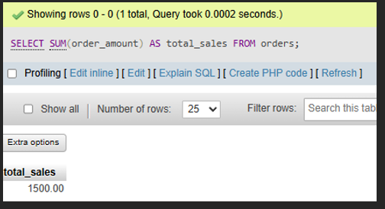

Lab 1: Write a PL/SQL block using an IF-THEN condition to check the department of an employee.
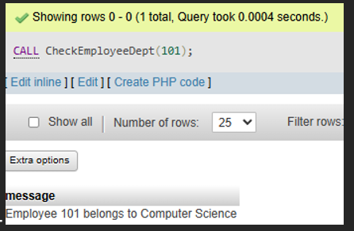
• Lab 2: Use a FOR LOOP to iterate through employee records and display their names.
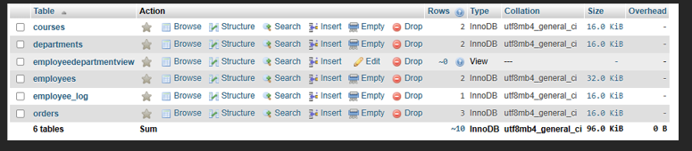

Lab 1: Write a PL/SQL block using an explicit cursor to retrieve and display employee details.
• Lab 2: Create a cursor to retrieve all courses and display them one by one.
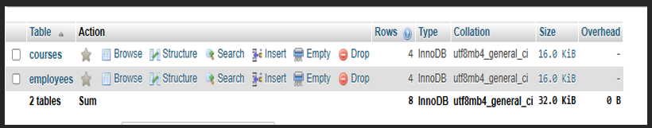

Lab 1: Perform a transaction where you create a savepoint, insert records, then rollback to the savepoint.
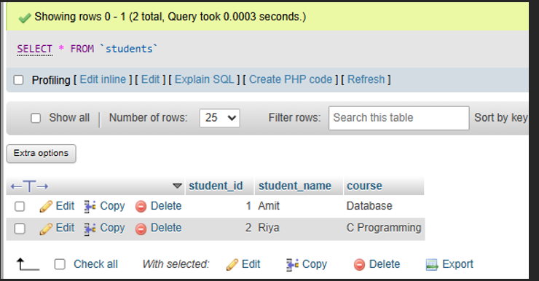
• Lab 2: Commit part of a transaction after using a savepoint and then rollback the remaining changes.
